Assessment Report

1) As per your understanding of Kabaddi, describe the columns of provided dataset (one line for each column).
Column Name | Description
Season_ID | Unique identifier representing the Kabaddi season in which the match was played.
Match_No | Serial number assigned to each match within the season.
Event_Number | Unique event identifier representing each raid event recorded in the dataset.
Match_Raid_Number | Sequential raid number within the entire match.
Team_Raid_Number | Raid sequence number for a particular team during the match.
Half | Indicates whether the raid occurred in the first half or second half of the match.
Raiding_Team_Name | Name of the team that is performing the raid.
Raider_Name | Name of the player from the raiding team who is attempting the raid.
Number_of_Defenders | Total number of defenders present on the mat when the raid takes place.
Raid_Number | Raid count or identifier for that specific raid attempt.
Raid_Length | Duration of the raid in seconds from the start of the raid until completion.
Outcome | Result of the raid from the raider’s perspective (Successful, Unsuccessful, or Empty).
Raiding_Team_Points | Points scored by the raiding team during that raid.
Defending_Team_Points | Points scored by the defending team during that raid.
Defending_Team_Name | Name of the team defending against the raid.
Defender_1_Name | Name of the primary defender involved in the tackle attempt.
Defender_2_Name | Name of the secondary defender involved in the tackle attempt.
Attacking_Skill | Type of attacking technique used by the raider during the raid.
Defensive_Skill | Type of defensive technique used by the defenders to stop the raider.
Counter_Action_Skill | Counter technique applied during the raid, either by the raider or defenders in response to the opponent’s action.

2) Using this data, write codes to fetch the following information (Use Any of SQL/Python):
a) Find Overall Raiding Team’s Total Raids and Successful Raids respectively.
Code- 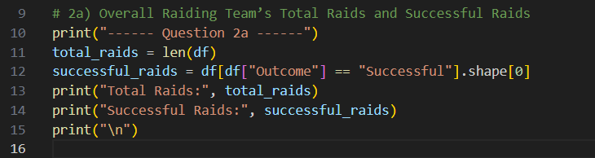
Output-
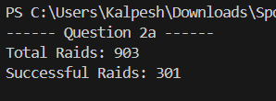

b) Find Overall Defending Team’s Total Tackles and Successful Tackles respectively.
Code- 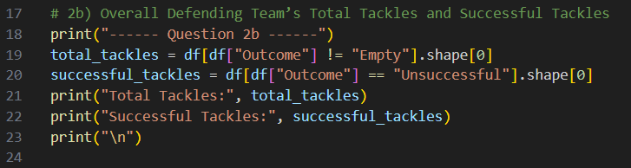
Output-
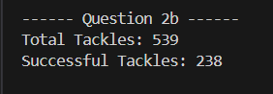

c) Find Raiding Team’s Successful Raids against 6-7 Defenders ONLY.
Code- 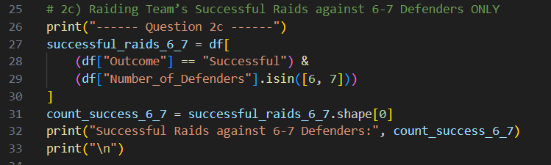
Output-
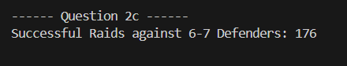
d) Find Defending Team’s Successful Tackles against 1-2-3 Defenders ONLY.
Code- 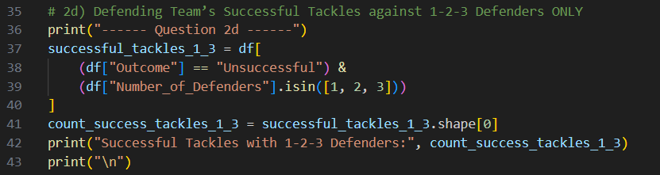
Output-
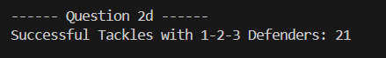

e) Find Raiding Team’s Do_or_Die Raids Success Rate (i.e., ratio of Succ_Do_or_Die Raids and Total Do_or_Die Raids).
Code- 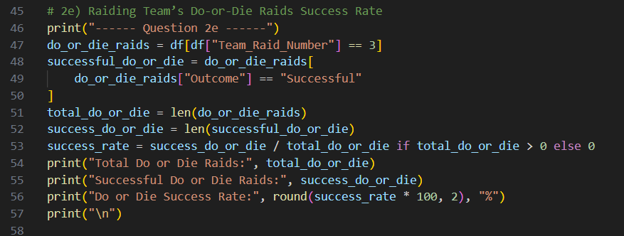
Output –
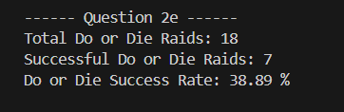

3) Using this data, create a suitable visualization to show the following (using any visualization tools):

a) Distribution of Raids (counts and percentage) for any Raider (use Raider Name column)
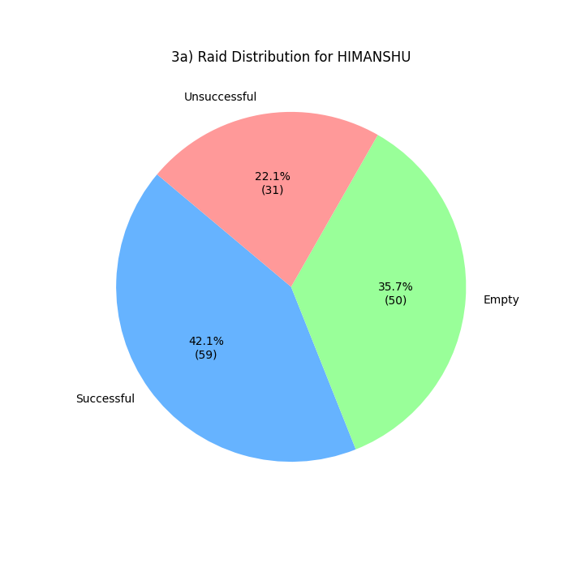
b) Distribution of Tackles (counts and percentage) for any Defender (use Defender_1_Name column)
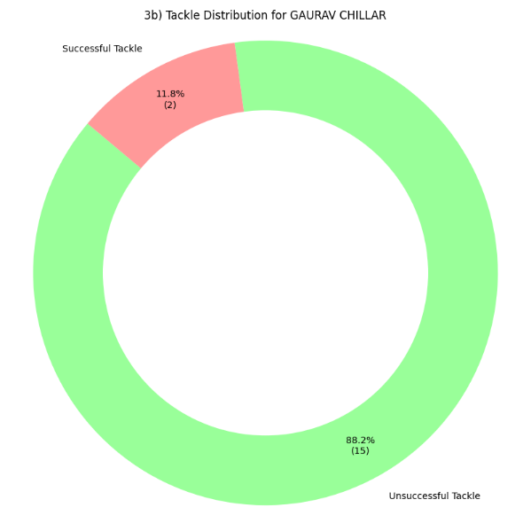

c) Plot Attacking Skills Distribution for any Raider.
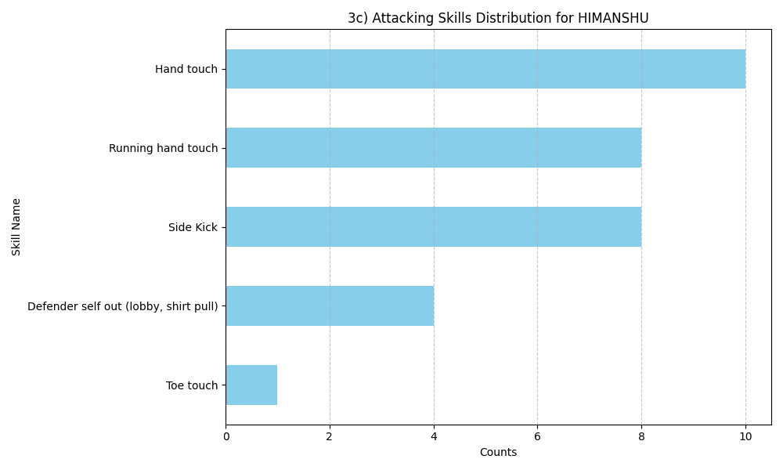

d) Plot Defensive Skills Distribution for any Defender.
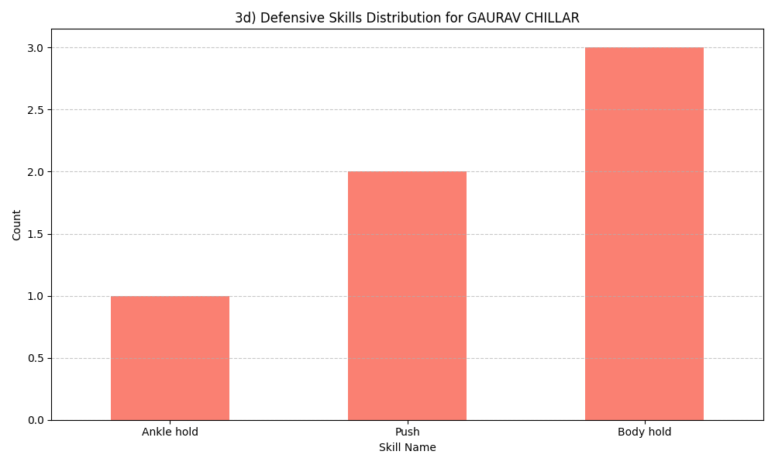

Full Code-
import pandas as pd
import matplotlib.pyplot as plt
import seaborn as sns

file_path = "SportsKPI_Kabaddi_Dataset_for_Assessment_.xlsx"
df = pd.read_excel(file_path)

df.columns = df.columns.str.strip()
#print("Dataset Loaded Successfully\n")

# 2a) Overall Raiding Team’s Total Raids and Successful Raids
print("------ Question 2a ------")
total_raids = len(df)
successful_raids = df[df["Outcome"] == "Successful"].shape[0]
print("Total Raids:", total_raids)
print("Successful Raids:", successful_raids)
print("\n")

# 2b) Overall Defending Team’s Total Tackles and Successful Tackles
print("------ Question 2b ------")
total_tackles = df[df["Outcome"] != "Empty"].shape[0]
successful_tackles = df[df["Outcome"] == "Unsuccessful"].shape[0]
print("Total Tackles:", total_tackles)
print("Successful Tackles:", successful_tackles)
print("\n")

# 2c) Raiding Team’s Successful Raids against 6-7 Defenders ONLY
print("------ Question 2c ------")
successful_raids_6_7 = df[
(df["Outcome"] == "Successful") &
(df["Number_of_Defenders"].isin([6, 7]))
]
count_success_6_7 = successful_raids_6_7.shape[0]
print("Successful Raids against 6-7 Defenders:", count_success_6_7)
print("\n")

# 2d) Defending Team’s Successful Tackles against 1-2-3 Defenders ONLY
print("------ Question 2d ------")
successful_tackles_1_3 = df[
(df["Outcome"] == "Unsuccessful") &
(df["Number_of_Defenders"].isin([1, 2, 3]))
]
count_success_tackles_1_3 = successful_tackles_1_3.shape[0]
print("Successful Tackles with 1-2-3 Defenders:", count_success_tackles_1_3)
print("\n")

# 2e) Raiding Team’s Do-or-Die Raids Success Rate
print("------ Question 2e ------")
do_or_die_raids = df[df["Team_Raid_Number"] == 3]
successful_do_or_die = do_or_die_raids[
do_or_die_raids["Outcome"] == "Successful"
]
total_do_or_die = len(do_or_die_raids)
success_do_or_die = len(successful_do_or_die)
success_rate = success_do_or_die / total_do_or_die if total_do_or_die > 0 else 0
print("Total Do or Die Raids:", total_do_or_die)
print("Successful Do or Die Raids:", success_do_or_die)
print("Do or Die Success Rate:", round(success_rate * 100, 2), "%")
print("\n")

#Q3 Visualizations

# 3a) Distribution of Raids (counts and percentage) for any Raider
raider_name = "HIMANSHU"
raider_df = df[df['Raider_Name'] == raider_name]
raid_outcomes = raider_df['Outcome'].value_counts()

def label_formatter(pct, allvals):
absolute = int(round(pct/100.*sum(allvals)))
return f"{pct:.1f}%\n({absolute:d})"
plt.figure(figsize=(7, 7))
plt.pie(raid_outcomes, labels=raid_outcomes.index,
autopct=lambda pct: label_formatter(pct, raid_outcomes),
startangle=140, colors=['#66b3ff','#99ff99','#ff9999'])
plt.title(f'3a) Raid Distribution for {raider_name}')
plt.savefig('3a_raider_distribution.png')
plt.show()

# 3b) Distribution of Tackles (counts and percentage) for any Defender
defender_name = "GAURAV CHILLAR"
defender_df = df[df['Defender_1_Name'] == defender_name].copy()
tackle_map = {
'Unsuccessful': 'Successful Tackle',
'Successful': 'Unsuccessful Tackle',
'Empty': 'Empty Raid'
}
defender_df['Tackle_Outcome'] = defender_df['Outcome'].map(tackle_map)
tackle_outcomes = defender_df['Tackle_Outcome'].value_counts()
def label_fmt(pct, allvals):
absolute = int(round(pct/100.*sum(allvals)))
return f"{pct:.1f}%\n({absolute:d})"

my_colors = ['#99ff99', '#ff9999', '#66b3ff']
plt.figure(figsize=(8, 8))
plt.pie(tackle_outcomes,
labels=tackle_outcomes.index,
autopct=lambda pct: label_fmt(pct, tackle_outcomes),
startangle=140,
colors=my_colors,
pctdistance=0.85)

centre_circle = plt.Circle((0,0), 0.70, fc='white')
fig = plt.gcf()
fig.gca().add_artist(centre_circle)
plt.title(f'3b) Tackle Distribution for {defender_name}')
plt.axis('equal')
plt.tight_layout()
plt.savefig('3b_defender_distribution.png')
plt.show()

# 3c) Attacking Skills Distribution for any Raider
raider_skills = raider_df[
(raider_df['Attacking_Skill'].notnull()) &
(raider_df['Attacking_Skill'].str.strip() != '')
]['Attacking_Skill'].value_counts().sort_values(ascending=True)
plt.figure(figsize=(10, 6))
raider_skills.plot(kind='barh', color='skyblue')
plt.title(f'3c) Attacking Skills Distribution for {raider_name}')
plt.xlabel('Counts')
plt.ylabel('Skill Name')
plt.grid(axis='x', linestyle='--', alpha=0.7)
plt.tight_layout()
plt.savefig('3c_raider_skills.png')
plt.show()

# 3d) Defensive Skills Distribution for any Defender
defender_skills = defender_df[
(defender_df['Defensive_Skill'].notnull()) &
(defender_df['Defensive_Skill'].str.strip() != '')
]['Defensive_Skill'].value_counts().sort_values(ascending=True)
plt.figure(figsize=(10, 6))
defender_skills.plot(kind='bar', color='salmon')
plt.title(f'3d) Defensive Skills Distribution for {defender_name}')
plt.xlabel('Skill Name')
plt.xticks(rotation=0, ha='center')
plt.ylabel('Count')
plt.grid(axis='y', linestyle='--', alpha=0.7)
plt.tight_layout()
plt.savefig('3d_defender_skills.png')
plt.show()

